Mid-Atlantic CVTeam Clinical Analysis: Urgent Topics for Today’s Practice
April 15, 2023 | Virtual Event

Activity Overview
This activity focuses on analyzing late breaking clinical trials from ACC.23 so the CVTeam is up-to-date on the latest evidence-based treatments.

Target Audience
This activity is designed for an audience of physicians, physician assistants, pharmacists, nurses, and nurse practitioners.

Learning Objectives
Upon completion of the educational activity, participants should be able to:

- Evaluate if the newest therapies in cardiology are appropriate to introduce into practice.
- Prepare a plan for treatment that includes a team-based approach to care.
- Explain why late breaking trials either point to an immediate change in practice or if clinicians should wait for additional trials before implementing results.

Criteria for Success
Statements of credit will be awarded based on the participant's attendance. A statement of credit will be available upon completion of an online evaluation/claim credit form available at:

akhcme.com/MACCS

Please claim your credit by April 30, 2023.

If you have questions about this CE activity, please contact AKH Inc at JGoldman@akhcme.com.

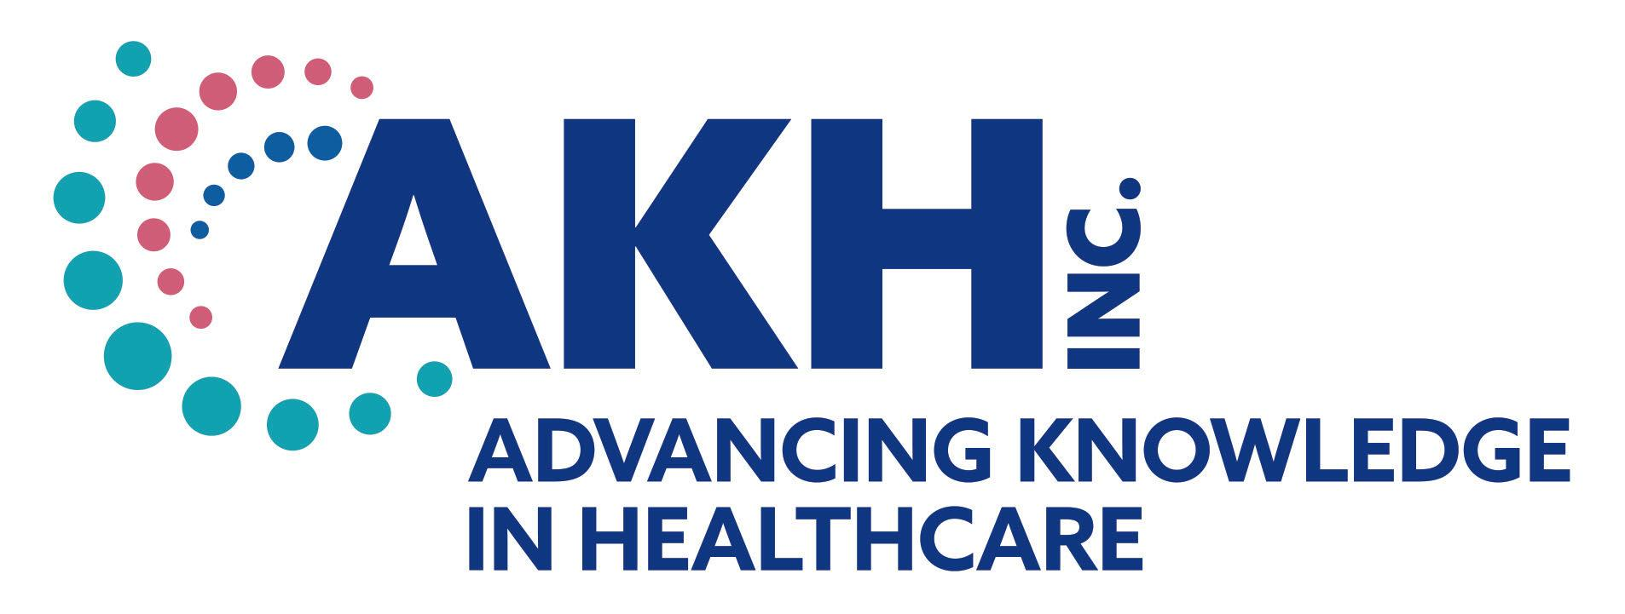
CE credit provided by AKH Inc., Advancing Knowledge in Healthcare.

In support of improving patient care, this activity has been planned and implemented by AKH Inc., Advancing Knowledge in Healthcare and Pennsylvania Chapter, American College of Cardiology (PA ACC). AKH Inc., Advancing Knowledge in Healthcare is jointly accredited by the Accreditation Council for Continuing Medical Education (ACCME), the Accreditation Council for Pharmacy Education (ACPE), and the American Nurses Credentialing Center (ANCC), to provide continuing education for the healthcare team.

Physicians
AKH Inc., Advancing Knowledge in Healthcare designates this live activity for a maximum of 2.0 AMA PRA Category 1 Credit(s)™. Physicians should claim only the credit commensurate with the extent of their participation in the activity.

Nurses
Credit being awarded: 2.0 ANCC contact hours

Pharmacists
AKH Inc., Advancing Knowledge in Healthcare designates this continuing education activity for 2.0 contact hours.

Physician Assistant
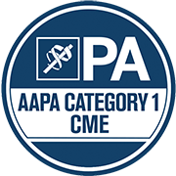
AKH Inc., Advancing Knowledge in Healthcare has been authorized by the American Academy of PAs (AAPA) to award AAPA Category 1 CME credit for activities planned in accordance with AAPA CME Criteria. This activity is designated for 2.0 AAPA Category 1 CME credits. PAs should only claim credit commensurate with the extent of their participation.

Nurse Practitioners
This activity has been planned and implemented in accordance with the Accreditation Standards of the American Association of Nurse Practitioners (AANP) through the joint providership of AKH Inc., Advancing Knowledge in Healthcare and Pennsylvania Chapter, American College of Cardiology (PA ACC). AKH Inc., Advancing Knowledge in Healthcare is accredited by the American Association of Nurse Practitioners as an approved provider of nurse practitioner continuing education. Provider number: 030803. This activity is approved for 2.0 contact hour(s) (which includes TBD hour(s) of pharmacology).

Commercial Support
There is no commercial support for this activity.

DISCLOSURES
Name | Relationship | Commercial Interest
Ashley Heatley, MSN, CRNP, FNP-C (faculty) | N/A | Nothing to disclose
John Lindsley, PharmD (faculty) | N/A | Nothing to disclose
Moses Mathur, MD, FACC (faculty) | Speaker | Abbott
Neleen Orsal, CRNP (faculty) | N/A | Nothing to disclose
Nosheen Reza, MD, FACC (faculty) | N/A | Nothing to disclose
Angela Street, CRNP, MSN, AACC (faculty) | N/A | Nothing to disclose
Gayley Webb, MSN, CRNP (faculty) | N/A | Nothing to disclose
Dorothy Caputo, MA, BSN, RN - VP, Healthcare Continuing Education and Operations | N/A | Nothing to disclose
Bernadette Makar, MSN, APRN-BC, NP-C (planner/reviewer) | N/A | Nothing to disclose
Dorothy Duffy, RPh (planner/reviewer) | N/A | Nothing to disclose
AKH Inc Staff and Planners | N/A | Nothing to disclose
PA ACC Staff and Planners | N/A | Nothing to disclose
All of the relevant financial relationships listed for these individuals have been mitigated.

Disclosures
It is the policy of AKH Inc. to ensure independence, balance, objectivity, scientific rigor, and integrity in all of its continuing education activities. The author must disclose to the participants any significant relationships with ineligible companies whose products or devices may be mentioned in the activity or with the commercial supporter of this continuing education activity. Identified conflicts of interest are mitigated by AKH prior to accreditation of the activity. AKH planners and reviewers have no relevant financial relationships to disclose.

Disclosure of Unlabeled Use and Investigational Product
This educational activity may include discussion of uses of agents that are investigational and/or unapproved by the FDA. Please refer to the official prescribing information for each product for discussion of approved indications, contraindications, and warnings.

Disclaimer
This course is designed solely to provide the healthcare professional with information to assist in his/her practice and professional development and is not to be considered a diagnostic tool to replace professional advice or treatment. The course serves as a general guide to the healthcare professional, and therefore, cannot be considered as giving legal, nursing, medical, or other professional advice in specific cases. AKH Inc. specifically disclaim responsibility for any adverse consequences resulting directly or indirectly from information in the course, for undetected error, or through participant&#39;s misunderstanding of the content.

